**Project Design Phase-II**

**Technology Stack (Architecture & Stack)**

|  |  |
| --- | --- |
| Date | 15 October 2022 |
| Team ID | PNT2022TMID14574 |
| Project Name | AI BASED DISCOURSE FOR BANKING INDUSTRY |
| Maximum Marks | 4 Marks |

Technical Architecture Steps:

1. User queries to the Chat Bot
2. Bot previews the query
3. Query is transferred to Watson Assistant
4. Natural Processing Language is used to understand the query
5. Watson Assistant sends the query
6. Watson finds the relevant response from cloud database
7. Queries and responses (sent and received) is stored in cloud database
8. All queries and related information is sent to the bank for improvement

**Technical Architecture :**

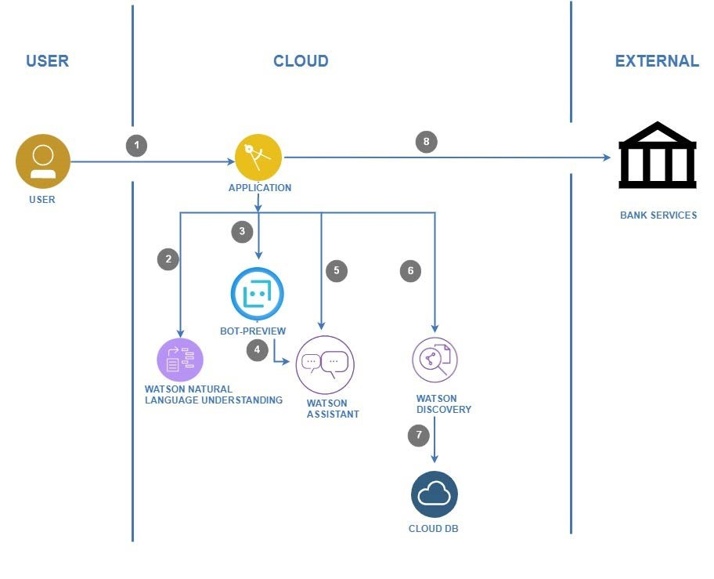

**Table-1 : Components & Technologies:**

|  |  |  |  |
| --- | --- | --- | --- |
| **S.No** | **Component** | **Description** | **Technology** |
| 1. | Bot Preview | A simple page is presented to the user with a chat layout that has an input box field available to get user queries and preset options are presented for the user to select. | HTML, CSS, JavaScript |
| 2. | Application Logic-1 | An input bar is provided that enables the user to type queries. | Java / Python |
| 3. | Application Logic-2 | Regularly asked queries or options are presented to the user. | IBM Watson STT service |
| 4. | Application Logic-3 | Processes responses to custom queries and displays a relevant response. | IBM Watson Assistant |
| 5. | Cloud Database | Queries and answers to queries are stored in the cloud and are accessed whenever a query is asked. | IBM Cloudant DB |
| 6. | External API-1 | It provides an interface between the application and the cloud to send the query from the application to the cloud. | Watson Assistant v2 API |
| 7. | External API-2 | A cloud based API that supports several cloud based applications and operations. | IBM Cloud API |
| 8. | External API-3 | Google Font API is a web service that supports high-quality open-source font files that can be used on your web designs easily. | Google Font API |
| 9. | Deep Learning Model | It is trained with several queries and uses that knowledge to provide relevant responses to queries with a good enough accuracy. | Deep Learning |
| 10. | Infrastructure (Server / Cloud) | Application Deployment on Local System / Cloud  Local Server Configuration: Flask Application  Cloud Server Configuration: IBM Cloud | Python Flask, IBM Cloud, Kubernates |

**Table-2: Application Characteristics:**

|  |  |  |  |
| --- | --- | --- | --- |
| **S.No** | **Characteristics** | **Description** | **Technology** |
| 1. | Open-Source Frameworks | List the open-source frameworks used | Python Flask, CSS Frameworks- Bootstrap, IBM Watson Chatbot  Framework |
| 2. | Security Implementations | General access control and the built-in security features of IBM Cloud are present. | IBM Watson Assistant, IBM Cloudant DB |
| 3. | Scalable Architecture | The architecture consists of three tiers, the client side, the web server and the cloud server. Each of these can be scaled as per requirements. | Client Side: Flask (Python)  Web Server: IBM Watson Assistant  Cloud Server: IBM Cloud |
| 4. | Availability | The chatbot is available 24/7 on almost all devices that support an internet browser. | IBM Cloud, Flask (Python) |
| 5. | Performance | Responds to several thousands of queries at the same time. | IBM Load Balancer, IBM Cloud |